**BRAKING**

# Objective

* Slow down the vehicle when required by the driver
* Security system

# Determination of the brake balance

## Model

* **Hypothesis:**
  + Straight line, no turn
  + Symmetric vehicle
* **Inputs:**
  + Tyre data
  + Vehicle data (dimensions, weight, center of gravity, …)
  + Brake data (master cylinder diameters, calipers, brake pads, brake disc diameter)
  + Brake pedal ratio
  + Brake balance
* **Outputs:**
  + Pressure and force in the brake caliper
  + Force on the brake pedal to bock all 4 wheels
* 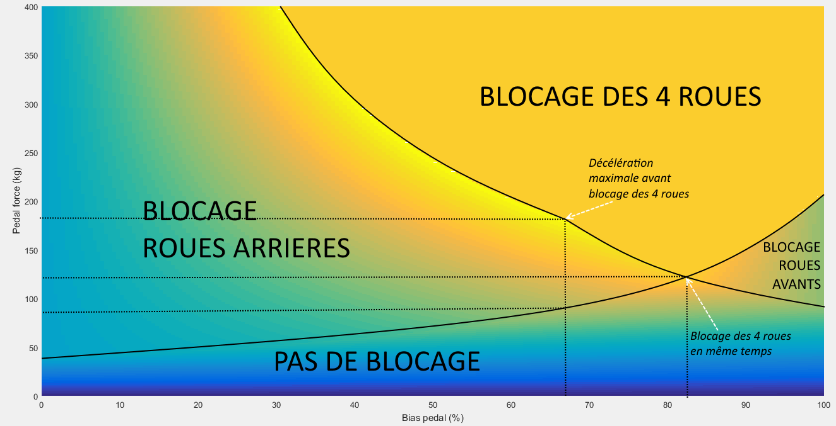Pressure inside the system has to be under 70 bars in typical use and 100 bars in high solicitation to ensure a reliable system.

Figure 1: Model used to determine the brake balance

# Values

* Brake balance: 65%
* Pedal ratio: 2/3
* Brake pedal force requirement (rules): 2000N
* 35-40kg for typical braking situation
* 50kg on the pedal to block the 4 wheels
* Master cylinder diameters: 14mm and 19.1mm